Case Study #14 PUD
Mariah Guthrie
Miami University

1. List all the food items that may contribute to GG’s condition and explain why.
GG consumed high amounts of fast food items, frozen and fried foods all of witch were high in fat. She also drank large amounts of coffee, pop and alcohol; all of witch increase acid secretion in the stomach. Increased acidity is a cause of PUD. Her intake of alcohol also causes a decrease in mucosal integrity (Nelms 361).
2. List any additional oral intake that may have contributed to GG’s condition and explain why.
GG took aspirin (NSAIDs) and smoked, both of these factors decrease blood supply witch like alcohol causes a decrease in mucosal integrity (Nelms 361).
3. List the non-oral stimulants (physical or psychological stress) that could contribute to GG’s condition and what she could do to change them.
Smoking is an added stressor, it decreases the blood supply and thus causes a decrease in mucosal integrity (Nelms 361). Stress is also another trigger, GG is having a hard time adjusting to becoming a single mom and having to go back to school to support her family.
4. List the symptoms of GG’s gastritis.
GG’s symptoms include abdominal pain, indigestion, and pain after meals.
5. Was a bland diet necessary? Explain and list the principles of the diet plan that you think GG should follow.
Since her doctor is not completely positive that she has gastritis it is not necessary for her to stick to a strict bland diet however she will need to make changes to her diet. She should restrict foods that cause an increase in acid secretion or foods that can irritate the stomach lining. Foods to avoid include caffeinated beverages, alcohol, foods high in fat and pepper. She stated that she drank some milk and the next day her stomach worse than ever, since milk is an irritant for her she should stay away from dairy products in order to reduce the chances of causing inflammation. In general she should stick to low fat foods, no caffeine, if she is going to eat meat she should eat low fat meats like poultry and fish cooked in low fat ways (boiling, baking) (Nelms 365).
6. What is the mechanism of action of the following medication GG is receiving;
Carafate: (sucralfate) is an anti ulcer medication and works by binding to the ulcer and protecting it from irritants like acid, enzymes and bile salts. It can help heal ulcers but it can npt prevent another ulcer form forming. Carafate can also make it harder for your body to absorb other types of medications so it should be taken by itself (Carafate, Drugs).
AlternaGel: (aluminum hydroxide) works as an antacid by increasing immune response and can help reduce phosphate levels (AlternaGel, Drugs).
Pepcid: (famotidine) is a histamine-2 blocker and works by decreasing acid production in the stomach (Pepcid, Drugs).
7. List the nutrient-drug interactions that are associated with these medications.
Carafate: Drug interactions include: abacavir, dolutegravir, paricalcitol, tivicay and Zamplar. Asprin, B12 and D3 should all be watched if you are taking them with Carafate (Carafate, Drugs).
AlternaGel: alternagel has lots of drug interactions: citric acid, sodium citrate, calcium citrate, potassium bicarbonate and sodium sulfonate to name a few. AlternaGel should not be taken with food because if consumed together it can alter your kidney function. You should not consume food within 2-3 hours of taking AlternaGel (AlternaGel, Drugs).
Pepcid: Major drug interactions include: atazanavir, Reyataz, tizanine, and Zanaflex. Other drug interactions include: nicotine, aspirin, Lipitor, fish oil, Tylenol and Xanax. B12 and D3 absorbtion can be affected by Pepcid (Pepcid, Drugs).
8. What are GG’s IBW and percent of IBW? (appendix A, tables 7 and 8)
IBW= 100lb +10lb = 110lbs or 50kg
% IBW= 98/110 = 89%
9. Estimate her daily energy needs using the Harris-Benedict equation and appropriate stress factor (Appendix A, Table 17).
EER= 655.1 + (9.563 x 50) + (1.850 x 157cm) – (4.676 x 27)
= 655.1 + 478.15 +290.5 -126.3
=1297kcal 1300kcal
Stress factor (1.5) x 1300kcal = 1950kcal
10. What might be the cause of the LUQ pain along with her usual pain? (consider the enzymes that are elevated).
She had elevated levels of amylase and alkaline phosphate witch shows issues with the pancreas, it can also be a predictor of gull stones. If the levels are not reduced to normal levels it can cause damage to the liver. These high levels were most likely caused by her continued use of aspirin (Robin, Suzanne).
11. In the second set of lab values, glu, BUN, Cr, ser alb, Na, K, Cl, hgb, and hct all dropped. This probably means that GG was:
These combination of lab values indicates that she is dehydrated when the labs were drawn.
12. In the second set of lab values, serum amylase, AST, and ALT all dropped. This probably means that:
The enzymes were elevated due to alcohol.
13. Refer to the two lab tables again, and note that two days after admission, GG’s Alk Phos and CPK remained essentially uncharged.
They remained unchanged because they are not affected by alcohol or dehydration.
14. What diagnostic test(s) (not lab values) indicate(s) that GG has an ulcer?
The doctors will test for H. Pylori witch is associated with ulcerative infections. In order to test for H. pylori they can use samples form your breath, stool or blood. An endoscopy is a way to look via a camera on a hose to visually pass though your digestive tract to see if there are any ulcers present. An endoscopy is more common if you are older, experiencing bleeding or have a recent weight loss (Peptic Ulcer).
15. Briefly sketch the anatomical position where GG’s ulcer can be found.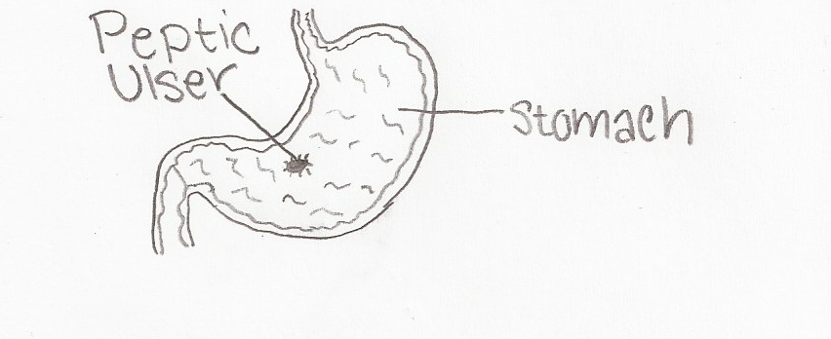

16. Define:
H2 antagonist: Drugs used to block the action of histamine on parietal calls in the stomach.
Proton pump inhibitor: a group of drugs whose main action is a pronounced and long lasting reduction of gastric acid production.
17. What is the mechanism of action of the following medications GG is receiving:
Nexium: (esomeprazole) is a proton pump inhibitor, and decreases acid produced in the stomach (Nexium, Drugs).
Amoxicillin: is a form of penicillin. It is used to treat infections caused by bacteria like tonsillitis, pneumonia, gonorrhea and infections of the body systems when used with clarithromycin it treats H. pylori infections (Amoxicillin, Drugs).
Clarithromycin: is an antibiotic and is used to treat infections of the skin and respiratory system, it can be used in combination with Amoxicillin to fight H. Pylori (Clarithromycin, Drugs).
18. GG was not receiving counsel at the time the major bleeding started. If you had the opportunity to counsel GG just before the bleeding, in what areas would you feel competent to counsel her and in what areas would you refer her to someone else? Investigate the agencies in your area that are available to provide assistance to someone like GG.
GG currently has a lot going on in her life and is having a hard time adjusting. She should be referred to a therapist or councilor that can help her with her stress, from recent divorce, becoming a single mom, returning back to school, and having to provide for her family. I will only be able to help her by advising her what changes she needs to make in her diet that will help her live with her condition and how to prevent it from happening again.
19. What is the significance of the dark stools?
Dark stools signifies blood in the stool. The blood could be form anywhere along the digestive tract.
20. Give the Pathophysiology for the cause of the following abnormal values: BUN, NH3, and WBC.
A BUN test reveals urea nitrogen levels if they are high the kidneys and liver might not be working properly. NH3 tests are usually used to note why a coma occurs or hepatic encephalopathy caused by liver damage. Some doctors use this test to monitor the effectiveness of treatment of hepatic encephalopathy (MayoClinic). WBC test monitors the number of white blood cells in the blood, a high count of WBCs indicates infection in the body.
21. GG was probably dehydrated on admission since she had been drinking. This means that some of her lab values were probably higher/lower than indicated.
22. After admission GG received packed cells and IV fluids. How would that affect the next set of lab values?
It will lower her lab values in the near future because of the influx of fluid.
23. Define the following items:
Packed cells: Packed cell volume
Abdominal tap: Removing fluid from the abdominal cavity.
Perforated ulcer: An ulcer extending through the wall or an organ.
Fistula: A narrow passage or duct formed by disease or injury, as one leading form an access to a free surface, or from one cavity to another
Exploratory Laparoscopy: An incision made into the abdomen it is used to visualize and examine the structures inside the abdominal cavity.
Billroth I: An operation in which the pylorus is removed and the proximal stomach is attached directly to the duodenum.
Vagotomy: the surgical severance of vagus nerve fibers, performed to reduce acid secretion by the stomach.
24. Sketch a Bilroth I
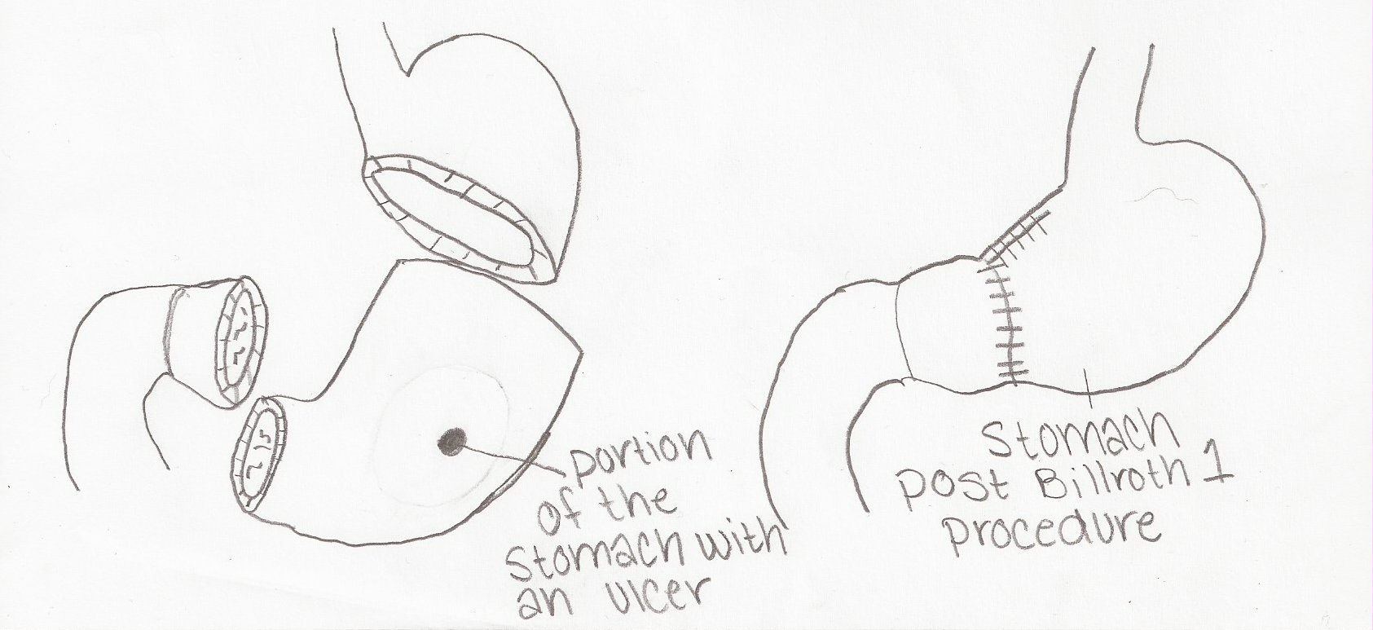
25. Compare a Bilroth I to a Billroth II as to anatomical changes as well as to dietary changes if any.
Both procedures are used to treat patients with ulcers, like GG, or patients with cancer. The procedure used depends on the placement and severity of the ulcer. In the Bilroth I procedure is a partial gastrectomy and the proximal end of the duodenum is connected to the distal end of the stomach. The Billroth II procedure is also a partial gastrectomy and the proximal end of the duodenum is closed off and the end of the stomach is connected with the jejunum (Bilroth’s operation I).
26.Calculate GG’s energy and protein needs
Resting Energy
10 x wt(kg) +6.25 x ht(cm)-5 x age-161
10 x 44.5kg +6.25 x 157.48 cm -5 x 27 -161
445 +984.25- 135 -161 = 1133.25 kcal 1100 kcal
EER
EER= 655.1 + (9.563 x 50) + (1.850 x 157cm) – (4.676 x 27)
= 655.1 + 478.15 +290.5 -126.3
=1297kcal 1300kcal
Stress factor (1.5) x 1300kcal = 1950kcal
Protein
1950 x .15 = 292.5g 290g
27. List the principles of a postgastrectomy diet and briefly describe the scientific basis for each principle.
Its important to put GG on an “anti dumping diet in order to prevent dumping syndrome.
She needs:
- A diet high in protein and fat
- Simple sugars should be avoided to prevent hyperosolality and hyperglycemia
- Avoid lactose
- Liquids should be consumed between meals
- Meals should be spaced out to 5-6 small meals per day
- Lie down after eating
- Prevent nutrient deficiencies (Nelms, 366).
28. Is it possible that GG’s diet will ever change or do you believe she will be on a postgastrectomy diet for the rest of her life? Explain your answer.
Due to the fact that after GG was given a diagnosis of an ulcer she returned to her old diet of eating fatty foods when the second semester of school started and stressors started to increase further. After she returned to her diet her symptoms worsened. Because her symptoms worsened after retuning to her diet it is not feasible for her to return to her diet of high fat foods. She may not have to be on a strict postgastrectomy diet but she will hve to monitor what she eats.
29. If GG were to be hospitalized for an extended period of time and required a tube feeding via duodenum or jejunum, what characteristics would be appropriate for the tube feeding you would use?
For a tube feeding diet she would have to have frequent meals that are very nutrient dense because she would not be able to tolerate a lot of cc’s at one time. It is also important that she is checked regularly for nutrient deficiencies and malnutrition.
30. Using the table below, compare several of the enteral nutritional supplements that would be appropriate for GG.
Product | Form | Cal/mL | Pro g | Cho g | Fat g | NA mg | K mg | Kg water | Vol. to meet RDA
Nutren 1.5 |  | 1.5 | 60 | 169 | 68 |  |  | 430 | 1,000
Isosource HN |  | 1.2 | 53 | 160 | 39 |  |  |  | 1,165
Diabetisource AC |  | 1.2 | 60 | 100 | 59 |  |  |  | 1,200
Nutrin replete fiber |  | 1.0 | 62 | 113 | 34 |  |  |  | 1,000
Optimental |  | 1.00 | 51 | 139 | 28 |  |  |  | 1422

Resources
Bilroth’s Operation I. Whonamedit? Retrieved from
http://www.whonamedit.com/synd.cfm/2730.html.
Drugs, Drug datatbase. Copyright 2015. Retrieved from http://www.drugs.com/.
Nelms, M., Sucher, K., Lacey, K., Roth, S. Nutrition Therapy and Pathophysiology. 2/e.
Peptic Ulcer. (2015) Mayoclinic. Retrieved from http://www.mayoclinic.org/diseases-
conditions/peptic-ulcer/basics/tests-diagnosis/con-20028643.
Robin, Suzanne. High Levels of Alkaline Phosphatase & Pancreatitis. Retrieved from
http://www.livestrong.com/article/412083-high-levels-of-alkaline-phosphatase-
pancreatitis/.

